

**Luz Negron**

**Children Services & Parent Support and Training Program  
3125 Myers Street 2nd Floor  
Riverside, CA 92503  
(951) 358-6858**

[**LMNegron@rcmhd.org**](mailto:LMNegron@rcmhd.org)

**Jacqualine Ebule**

**MHSA Administration  
2085 Rustin Ave  
Riverside, CA 92507  
Office: 951-955-7118  
Fax: 951-955-7205**

[**JAEbule@rcmhd.org**](mailto:JAEbule@rcmhd.org)

**Volunteer Services Coordinators**

**Volunteer Application and Personal History Statement**

|  |  |
| --- | --- |
| **VOLUNTEER APPLICATION FOR:** | |
| **Family Advocate Program** |  |
| **Cultural Competency Program** |  |
| **Children’s Services and Parent Support & Training Program** |  |
| **Student/Internship (GIFT Program)** |  |
| **Peer Support Specialist Program** |  |
| **Behavioral Health Commission** |  |
| **Clinic Volunteer/Other** |  |

|  |  |  |  |  |  |  |  |  |
| --- | --- | --- | --- | --- | --- | --- | --- | --- |
| **CONTACT INFORMATION** | | | | | | | | |
| Date: | | | | | Referred by: | | | |
| Last Name: | | | | | First Name: | | | |
| Address: | | | | | City: | | | |
| State: | | | | | Zip Code: | | | |
| Birth Date: | | | | | Days Available: | | | |
| Home Phone: | | | | | Cell Phone: | | | |
| Email: | | | | | Alternate Email: | | | |
| Please take a minute to describe your ideal volunteer opportunity.    What is your purpose for volunteering? Why are you volunteering? | | | | | | | | |
| **To help us match your skills with your volunteer assignment, please check those skills you have acquired through work and volunteer experiences.** | | | | | | | |
| **Skills** | | (√) | **Skills** | | (√) | **Skills** | (√) |
| **OFFICE SKILLS** | |  | **Person to Person Skills** | |  | **SOFTWARE PROGRAMS** |  |
| Clerical / Receptionist | |  | Documenting interactions | |  | E-mail/Outlook |  |
| Compose Letters/Memos | |  | Group Facilitation | |  | Windows |  |
| Mail Merge | |  | Customer Service | |  | MS Word |  |
| General Office | |  | Peer Counseling | |  | Power Point |  |
| Reports | |  | Outreach | |  | Access |  |
| Statistical | |  | Welcoming | |  | Publisher |  |
| Accounting | |  | Engagement | |  | Excel |  |
| Filing (Alpha/Numeric) | |  | Advocacy | |  | Internet |  |
| Copier/Scanner/Fax | |  | Resource Linkage | |  | **TELEPHONE** |  |
| Typing Speed:     wpm | | | Public Speaking | |  | # of Phone lines: |  |
| **TRANSCRIPTION** | |  | **SECOND LANGUAGE/s** | |  | Volume of calls   (circle one) |  |
| Medical | |  | Spanish | |  | Heavy Medium Light | |
| Legal |  | | Other: | |  |  |  |
| Meeting Minutes |  | |  | |  |  |  |

|  |  |  |  |  |
| --- | --- | --- | --- | --- |
| **Hobbies and Talents** | | | | |
|  | |  | | |
|  | |  | | |
|  | |  | | |
| **Please list all certificates, awards, licenses and professional designations you have that indicates your particular area of expertise or training relative to volunteer services.** | | | | |
| **Name of Certificate** | **Issuing Agency** | | **Certificate Number** | **Date** |
|  |  | |  |  |
|  |  | |  |  |
|  |  | |  |  |
|  |  | |  |  |

|  |  |
| --- | --- |
| **EDUCATIONAL BACKGROUND** | |
| School: | Graduated:      Year: |
| City: | State: |
| College or University: | Major: |
| Degree: | Year: |
| Graduate School: | Major: |
| Degree: | Year: |

**The following questions only apply to Applicants whose volunteer service requires driving. (Please complete the Authorization to Drive Form 30 and provide a copy of valid license & insurance.)**

|  |  |  |  |  |
| --- | --- | --- | --- | --- |
| **DRIVING INFORMATION** | | | | |
| **Driver License No.** | **State** | **Class** | **Expiration Date** | |
|  |  |  |  | |
| Has your driver license ever been suspended or revoked? | | | Yes | No |
| Are you minimally covered with auto liability insurance as required by the State of California? | | | Yes | No |

|  |  |  |  |  |
| --- | --- | --- | --- | --- |
| **MEDICAL INSURANCE INFORMATION** | | | | |
| Do you currently have a medical insurance?  If “Yes” please provide the following: | | | Yes | No |
| **Carrier** | **Policy Number** | **Coverage Period** | | |
|  |  |  | | |
|  |  |  | | |
|  |  |  | | |

By my signature below, I declare that all information provided on this document submitted to the Riverside County Department of Mental Health is true, accurate and complete. I understand that falsification of information is grounds for disqualification. I authorize the County and any of its agents to verify any information on this application and authorize the release of any such information. I release the County from any liability from seeking such information.

|  |  |
| --- | --- |
| **Signature:** | **Date:** |

|  |  |  |  |
| --- | --- | --- | --- |
| **OFFICE USE ONLY** | | | |
| Date Cleared: | TB Test Results | | Date of Enrollment: |
| Name of Supervisor: | | Date of Termination: | |
| Name of Site/Location: | | | |
| Notes: | | | |

Minor Applicants receiving a Live Scan will be accompanied with/by parent/guardian permission.

Parent/guardian of minor/s will have to sign a parent consent form (Parent Permission Form)



**LIABILITY INFORMATION**

Ordinance 440. Section 11- F

County Insurance

Such liability insurance as the county may carry shall be excess insurance over any other valid and collectable insurance, including that provided by the volunteer. Volunteers are not covered by workers compensation insurance.

The County of Riverside provides liability insurance while in the course and scope of the volunteer’s activity/responsibility except but not limited to the following.

* Willful, wanton acts.
* Abuse, sexual abuse, assault and battery
* Acts/activities not within the course and scope of the volunteer’s activities/responsibilities

COUNTY OF RIVERSIDE POLICIES

I understand that as a volunteer for the County of Riverside, I will not accept gifts, services or any type of compensation from those I serve as a result of the performance of my duties as a volunteer.

I understand that volunteers are to park their private vehicles in the Public Parking areas at the County Facilities. The County of Riverside is not responsible for the payment of fines resulting from parking in area’s designated for County employees.

I acknowledge that I have read and have been made aware of the Policies and Liability information for the County of Riverside as it stands. If you have any further questions regarding Volunteer Insurance I may contact Risk Management Division @ (951)955-3540 or the Department Volunteer Coordinator.

Volunteer Signature Date

Volunteer Coordinator or Designee Date

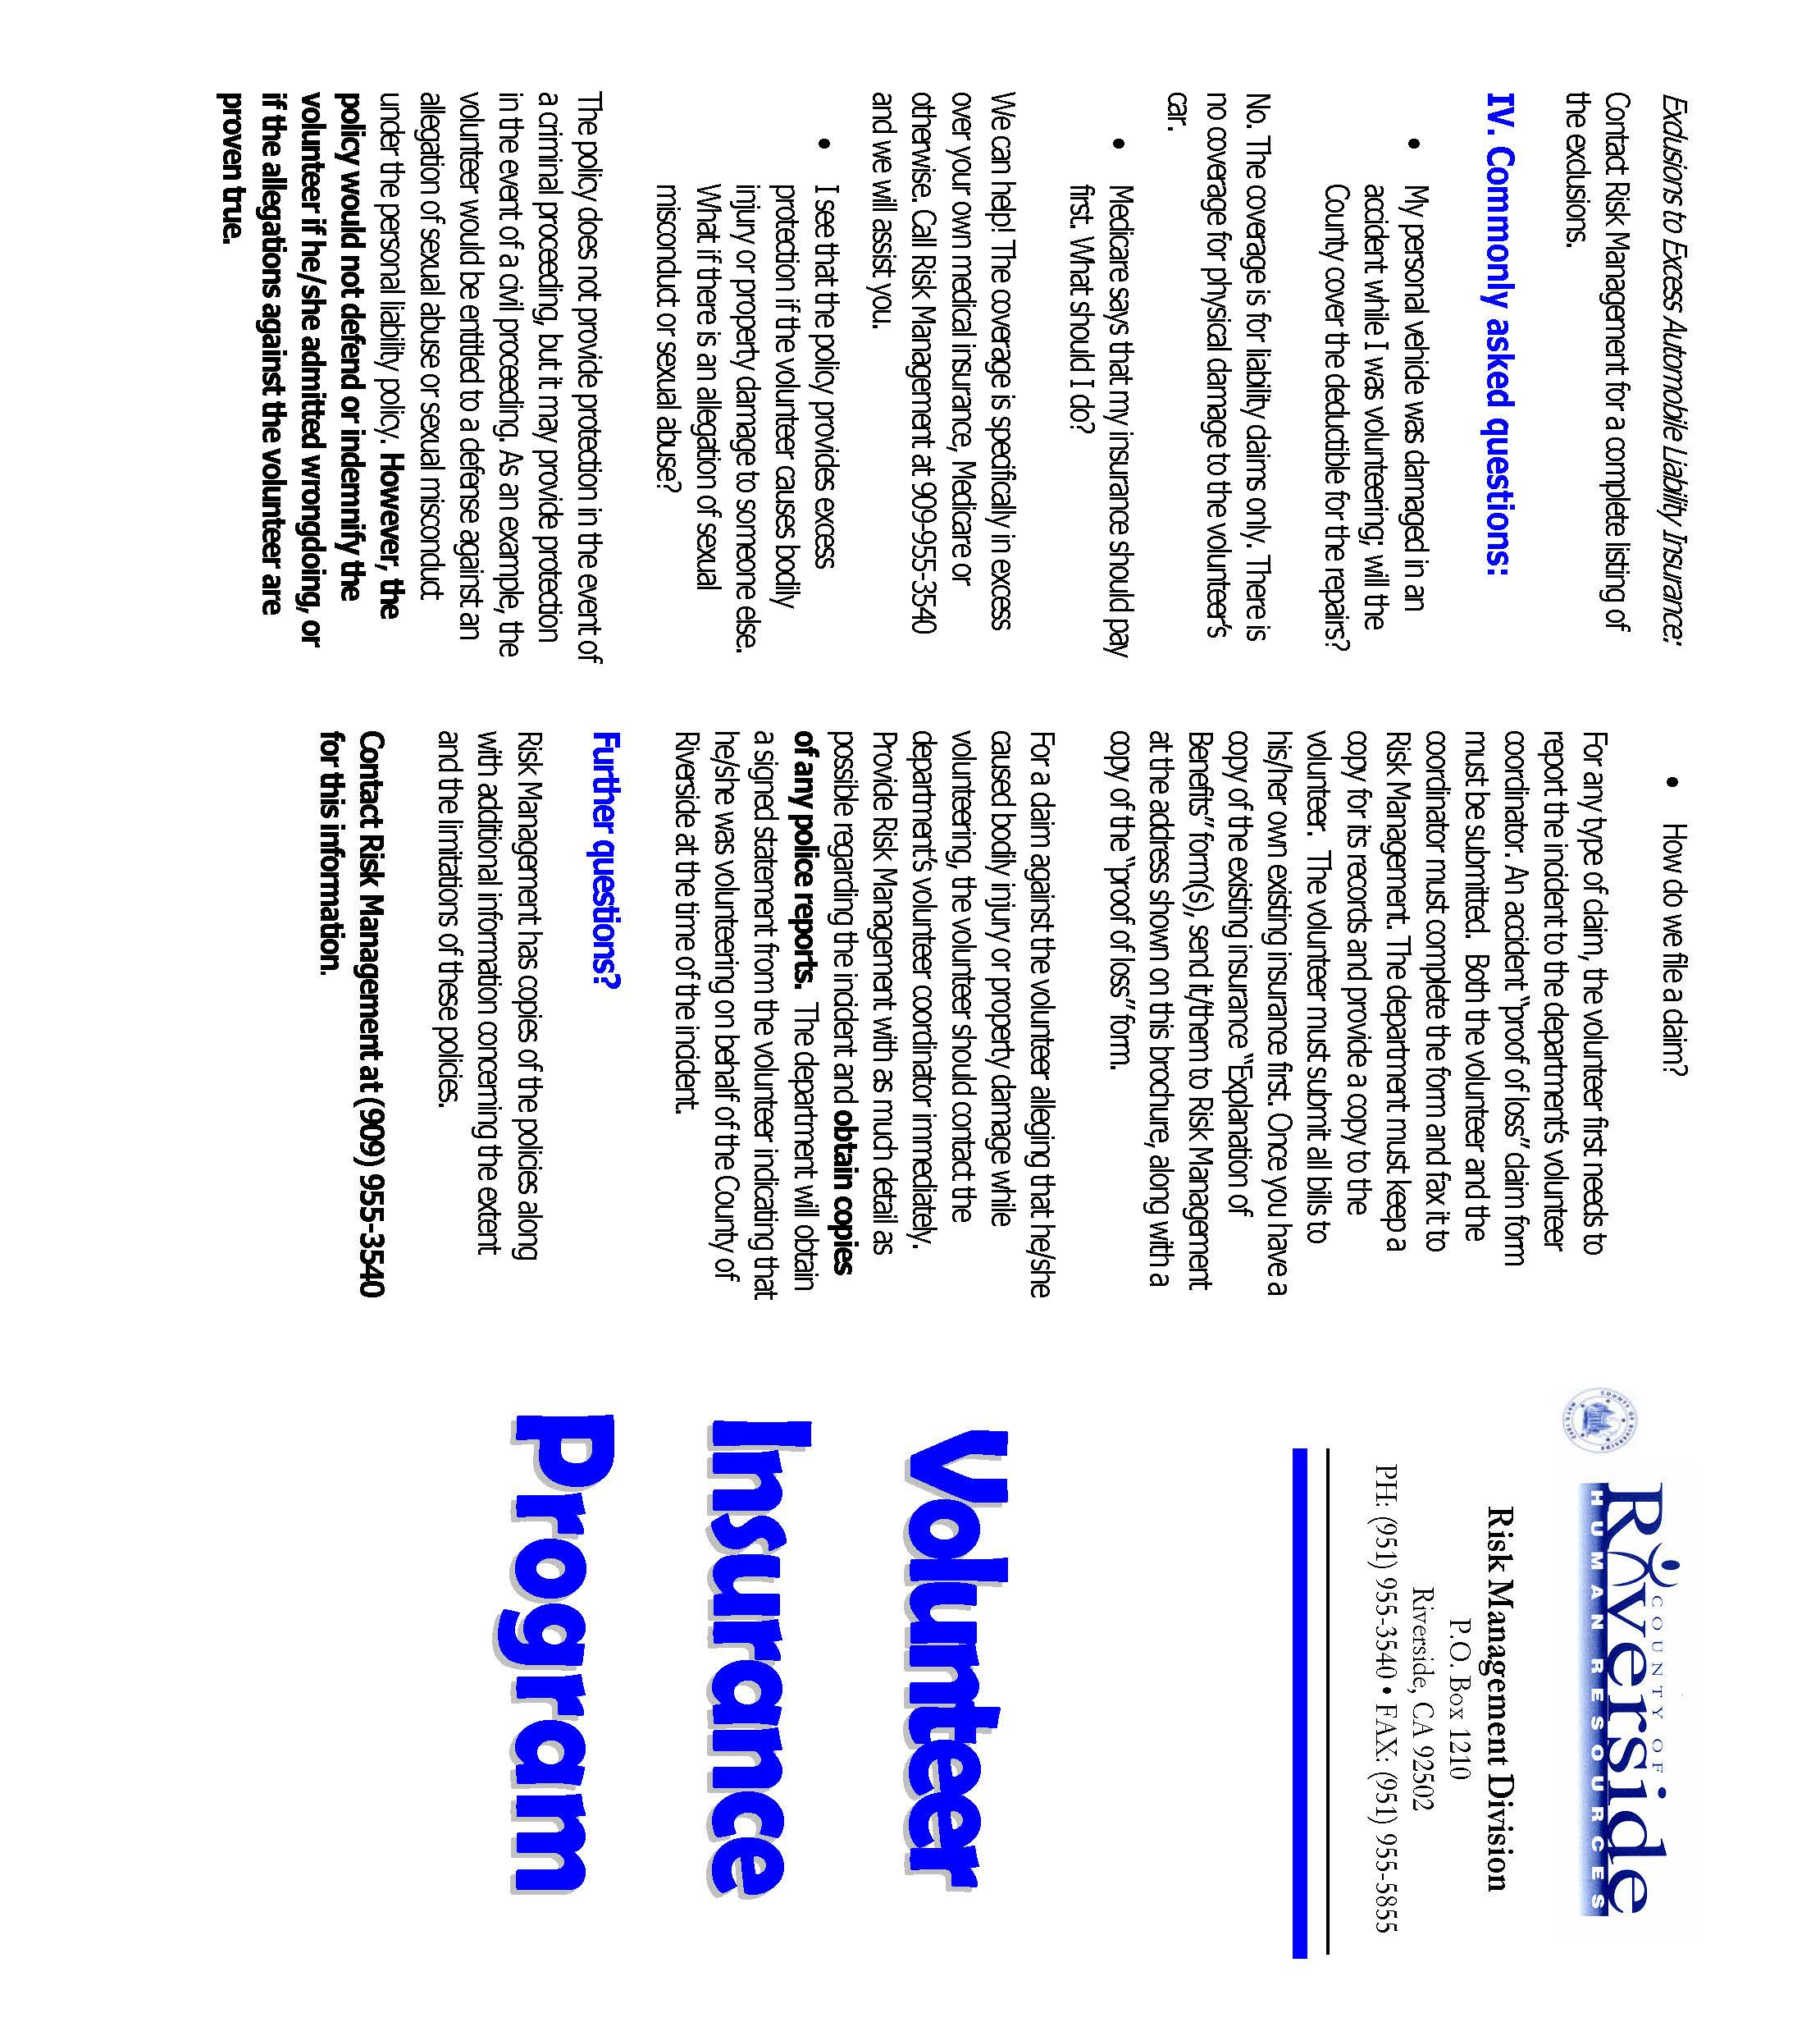

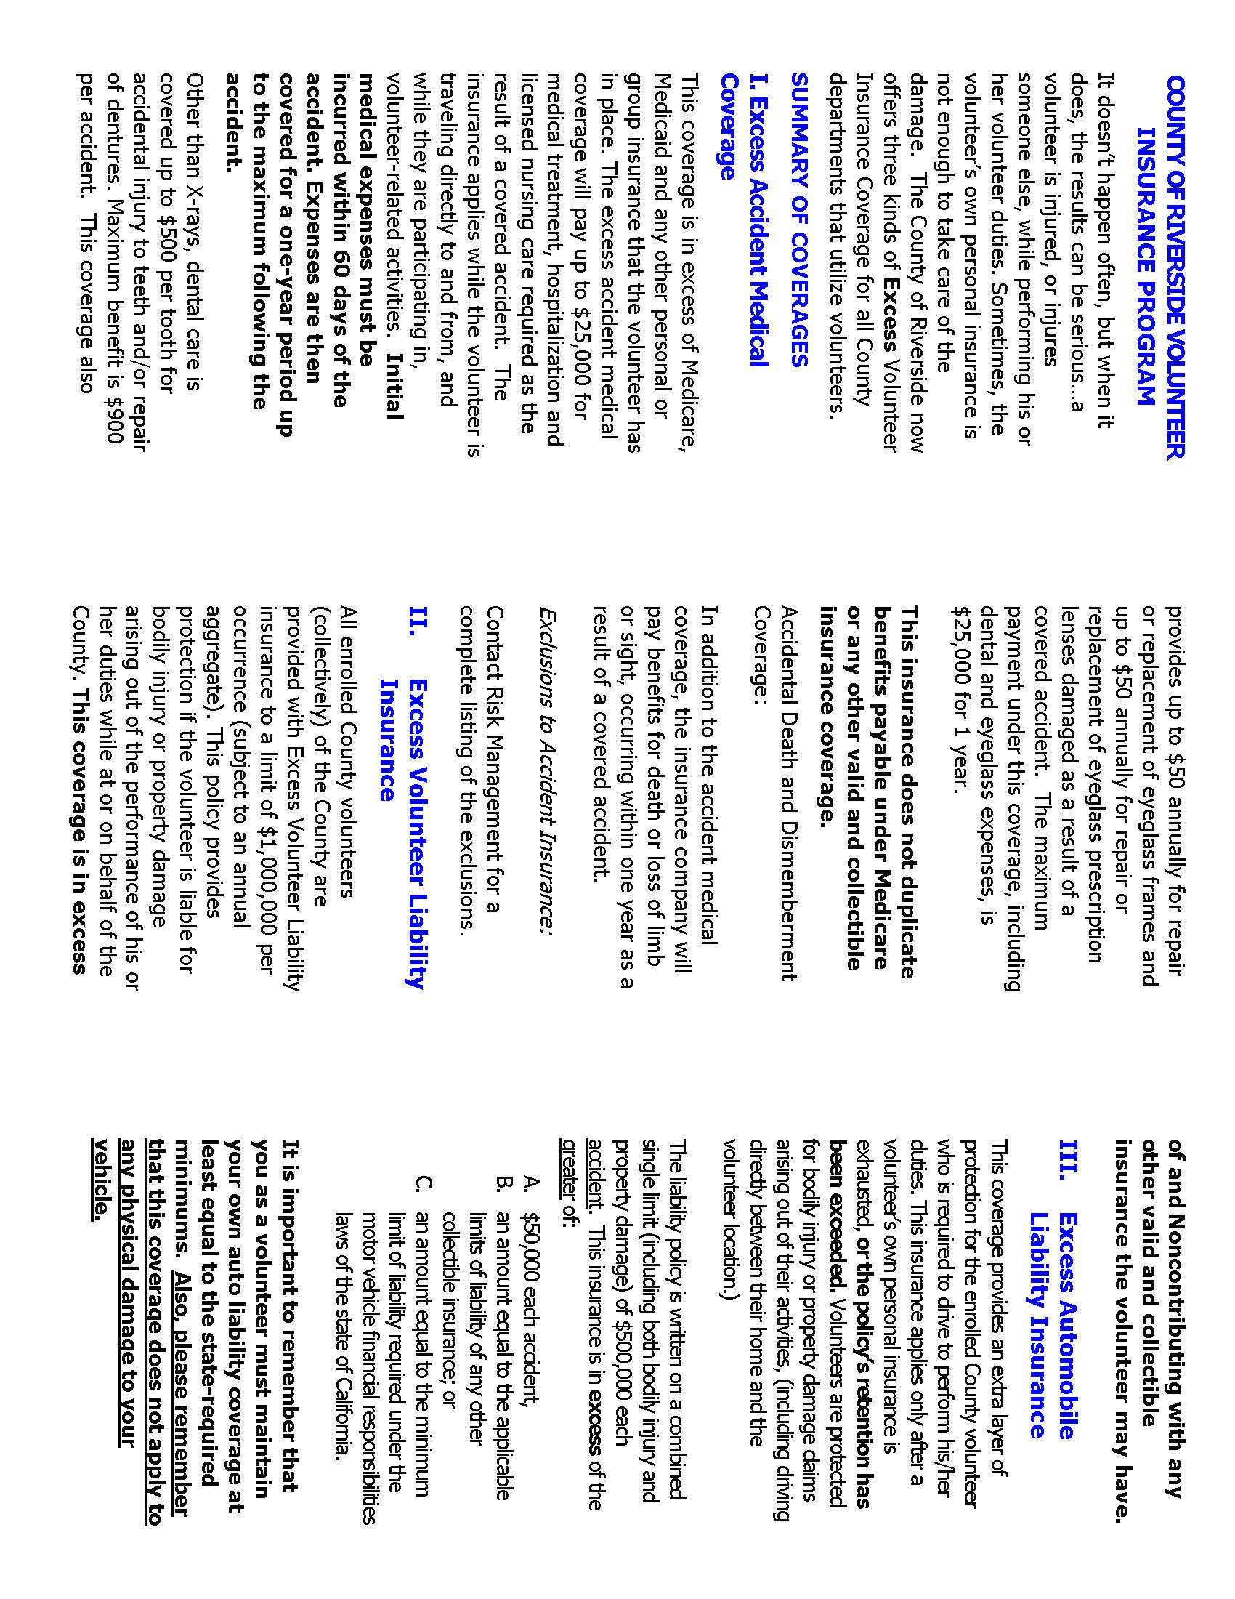



Riverside University Health System- Behavioral Health

2085 Rustin Ave., Riverside CA 92507

(951) 955-7118

**AGREEMENT OF CONFIDENTIALITY**

**FOR VISITOR(S) VOLUNTEER(S)**

All volunteers and/or visitors are required to abide by section No. 5328 of the California Welfare and Institution Code, and by Department policy to sign after acknowledgement of the following:

As a condition of working with Mental Health documents and/or being involved with persons who are receiving services from the Riverside County Department of Mental Health or as a visitor; I agree not to divulge to unauthorized persons, any information obtained in the course of such involvement, and not to publish or otherwise make public any identifiable information regarding such persons.

I recognize that the unauthorized release of confidential information may be subject to a civil action under provisions of the welfare and institution code.

_______________________________________

Volunteer Name – Please Print

_______________________________________ _________________

Volunteer Signature Date

_______________________________________ _________________

Volunteer Coordinator Signature Date



Riverside University Health System- Behavioral Health

2085 Rustin Ave., Riverside CA 92507

(951) 955-7118

|  |  |  |  |  |  |
| --- | --- | --- | --- | --- | --- |
| Program/Clinic: | | Immediate Supervisor: | | | |
| Last Name: | First Name: | | | Middle: | |
| Home Address: | | | | | |
| City: | | | State: | | Zip code: |
| Home #: | Cell #: | | | Fax: | |

Emergency & Medical Information  
 **EMERGENCY CONTACT(S)**

|  |  |  |
| --- | --- | --- |
| 1. Name: | | |
| Relationship: | Contact #: | Alternate #: |
| 2. Name: | | |
| Relationship: | Contact #: | Alternate #: |

Please understand this form is for your protection and will assist us in an attempt to prevent any problems from lack of awareness. In no way will this prevent your participation in the volunteer program. This information will be kept confidential.

|  |  |  |
| --- | --- | --- |
| Do you suffer from any of the following? | YES | NO |
| Asthma |  |  |
| Diabetes |  |  |
| Epilepsy |  |  |
| Back Problems |  |  |
| **Other:** |  |  |
| Do you have any of the following allergies? | YES | NO |
| Sun |  |  |
| Penicillin |  |  |
| Bee Sting |  |  |
| **Other:** |  |  |

If in an emergency, my emergency contact cannot be reached, I authorize the appropriate person in charge to have me transported to the nearest hospital for emergency care.

|  |  |  |  |
| --- | --- | --- | --- |
| Yes: | No: | Please Sign: | Date: |

