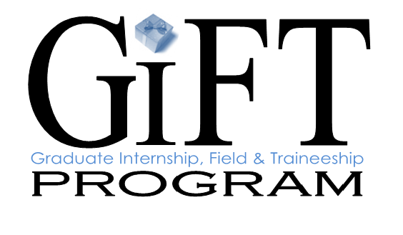

MHSA Workforce Education and Training Unit (WET) • 2085 Rustin Avenue • Riverside, California 92507

APPLICATION PACKET

Dear Candidate:

Thank you for your interest in the Riverside University Health System – Behavioral Health Graduate Internship, Field and Traineeship Program (GIFT Program)! This packet includes:

- Instructions for completing the application
- Application for the GIFT Program

If you have any questions, please contact Sheree Summers, Staff Development Officer, at GIFTProgram@rcmhd.org or call (951) 955- 7108.

Sincerely,
Sheree Summers
Staff Development Officer

Graduate Internship, Field and Traineeship Program (GIFT Program)

INSTRUCTIONS FOR COMPLETING THE APPLICATION

Please review the instructions below before completing the application. Incomplete applications will not be considered.

CONTACT INFORMATION Section:
- Provide accurate and up-to-date personal contact information.

INTERNSHIP INFORMATION Section: Please use the drop down menus where provided!
- University: Provide all requested University information.

- Field Advisor/Liaison: Provide the name and contact information for the university representative we would contact regarding your placement.

- Program: Indicate your discipline and the year of schooling you will be starting in the fall (Drop down menu provided).

- Indicate which days you will be available for placement in this agency. These will be the days that you are not in class.

- Please indicate your first and second choice of populations (type of client) that you would like to gain experience working with this upcoming year. (Drop down menu provided).

LANGUAGE ABILITY Section:
- Indicate if you speak a second language, including American Sign Language. Specify which additional language(s) you speak and if you read and write in that language.

QUESTIONS Section:
- Use the designated areas to answer the questions. Do not attach additional pages.

- Regarding question #5: We recognize that it is still vulnerable for people to talk about a mental health treatment history. This information will not be shared with perspective field sites without your permission. We want you to know that RCDMH is committed to the full integration of people with consumer or family member experience into our programs and workforce. We see this experience as an asset.

ACKNOWLEDGEMENTS Section:
- Read and check the boxes in this section before submitting your application.

SUBMISSION INSTRUCTIONS:
- Submit your completed application, with an electronic copy of your current resume, to the Staff Development Officer of Education at GIFTProgram@rcmhd.org.

Graduate Internship, Field and Traineeship Program (GIFT Program)

APPLICATION
CONTACT INFORMATION
Last Name, First Name |  | Date
Address |  | City | State, Zip Code
Cell Phone | Home Phone | Candidate’s Email

INTERNSHIP INFORMATION
Name of University

Address/Campus Location

Field or Practicum Advisor/ Liaison

Office Phone | Cell Phone
Program  Choose an item. | Have you been awarded a state stipend?  YES NO
How many hours are required for your program?  per week per quarter/semester | What days will you be in placement?  Monday Tuesday Wednesday  Thursday Friday
What population would you like to work with next year?

First Choice: Choose an item. Second Choice: Choose an item.

LANGUAGE ABILITY
Are you bilingual? If YES, please answer the additional question below. If NO, please skip to the “Questions” portion.

YES NO
What other language do you speak?  Language: | Speak:  YES NO | Read:  YES NO | Write:  YES NO

QUESTIONS
1. What is your motivation for seeking an internship/practicum with this agency?

2. In terms of your career, where do you see yourself in 5 years?

3. What populations (i.e. ages, diagnoses) are you interested in gaining experience with this year?

4. What diversity factors will you bring into this agency?

5. Tell me about your experience with, or a family member’s experience, as a consumer of mental health services.

ADDITIONAL INFORMATION
Please provide any additional information or comments:

ACKNOWLEDGEMENTS
By checking this box, you understand this program will expect a 16-24 hour a week
commitment for at least 8 months, even if this exceeds your academic requirements.

By checking this box you are confirming your understanding that, if selected, you will be required to
attend mandatory student trainings prior to starting your internship/practicum.

By checking this box, you are stating that the information on this application is true and correct.

